**Activity: Hosting a static web page in S3 2**

Part 1: Create S3 bucket 2

Part 2: Enable static web hosting on your bucket 3

Part 3: Upload the contents into S3 bucket 4

Part 4: Set up Route53 record to point to your bucket 6

Part 5 Clean up 7

**Activity: Terraform Challenge 8**

### 

### 

### Activity: Hosting a static web page in S3

#### Part 1: Create S3 bucket

Go to Services -> S3 -> Create Bucket

* Naming convention e.g. <name>s3.sctp-sandbox.com (e.g. jazeels3.sctp-sandbox.com) Untick “Block all public access” and acknowledge.
* Leave all else as default and click Create.
* Go to your bucket and click on the Properties Tab.
* Under Static website hosting, click Edit.
* Under Static website hosting, choose Enable.
* In Index document, enter the file name of the index document, typically index.html. Leave the others empty for now. Save the changes.
* Click on your bucket & Go to the Permissions tab, scroll down to **Bucket Policy** and click “Edit”.
* Here, enter the below code snippet, but **remember to change the bucket name placeholder <YOUR-BUCKET-NAME> to your own bucket name:**
* Once done, Save your changes.

| {  "Version": "2012-10-17",  "Statement": [  {  "Sid": "PublicReadGetObject",  "Principal": "*",  "Effect": "Allow",  "Action": [  "s3:GetObject"  ],  "Resource": ["arn:aws:s3:::<your-bucket-name>/*"]  }  ] } |
| --- |

#### 

#### Part 2: Enable static web hosting on your bucket

* Go to your bucket and click on the Properties Tab.
* Under Static website hosting, click Edit.
* Under Static website hosting, choose Enable.
* In Index document, enter the file name of the index document, typically **index.html.** Leave the others empty & Save the changes.

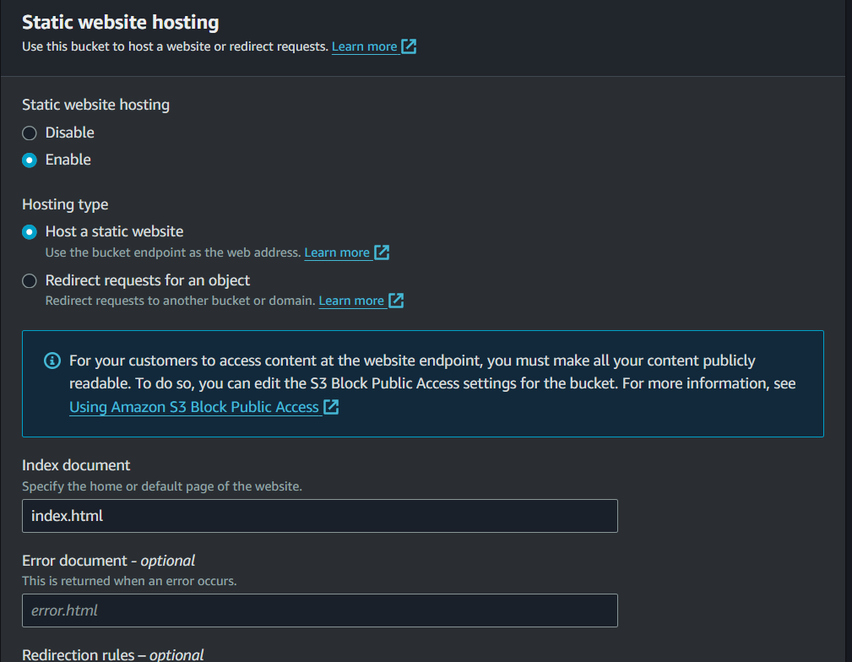

* Under Static website hosting, note the Endpoint. The Endpoint is the website endpoint for your bucket. After you finish configuring your bucket as a static website, you can use this endpoint to test your website.

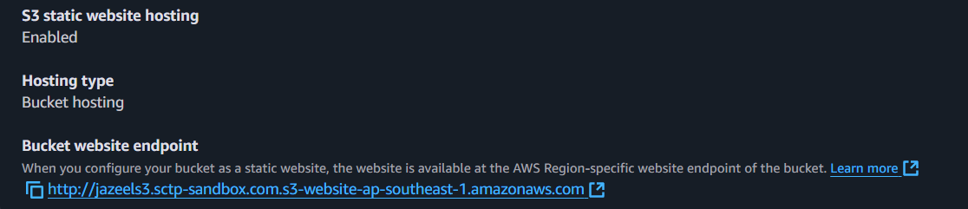

#### 

#### Part 3: Upload the contents into S3 bucket

You can clone the sample static website here or any index.html file as well to upload into your bucket: <https://github.com/cloudacademy/static-website-example>

**IMPORTANT NOTE: cd to the folder which contains your static files that you want to upload to s3 before you run any of the commands shown below:**

You can use any of the 3 commands mentioned below to copy the files into s3.**You have to use the “--recursive” flag for mv and cp commands because these 2 commands are used only to move a single file/object by default.** The **s3 sync** command can be used to sync all of your local files **within your directory** with your s3 bucket.

* aws s3 cp . s3://<bucketname> --recursive
* aws s3 mv . s3://<bucketname> --recursive
* aws s3 sync . s3://<bucketname>

If you have cloned the sample website from above, you can use the following command to copy only the required files into your s3 bucket

| aws s3 sync . s3://<your-bucket> --exclude "*.MD" --exclude ".git*" |
| --- |

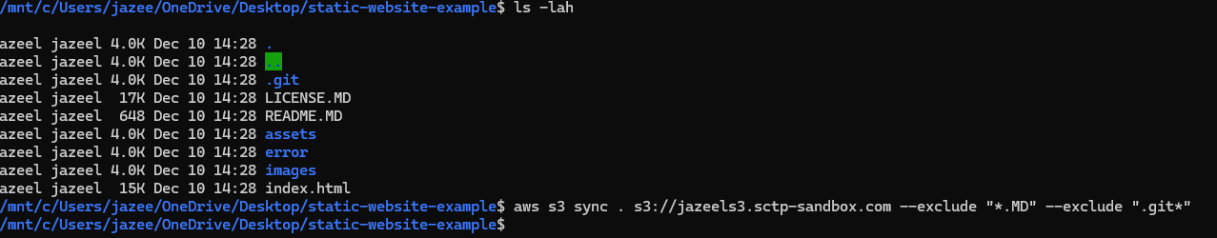

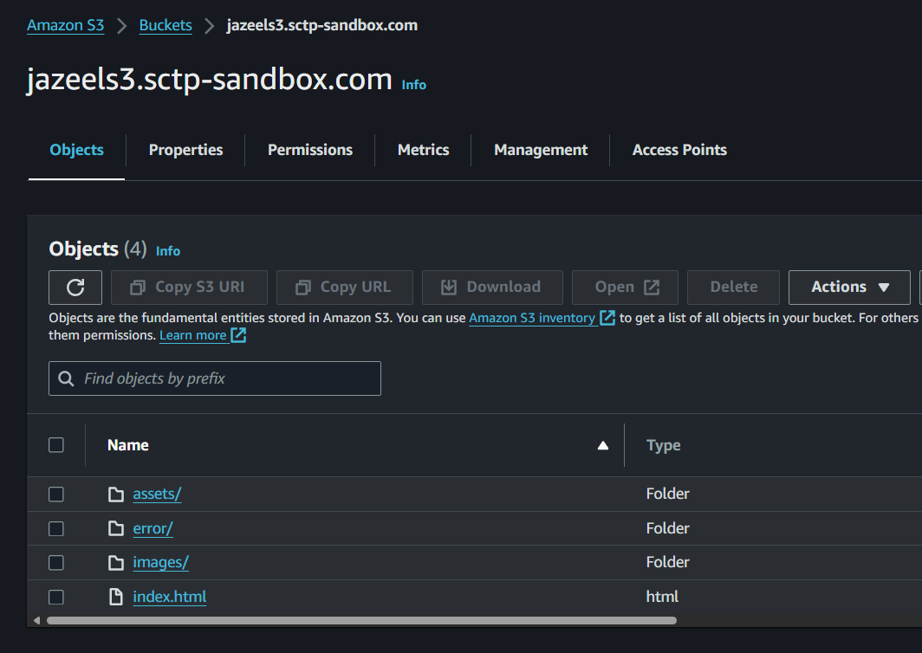

* Go to the public URL of your S3 bucket (this can be found in the Properties tab under Static Website Hosting). You will be able to view the website you have deployed.

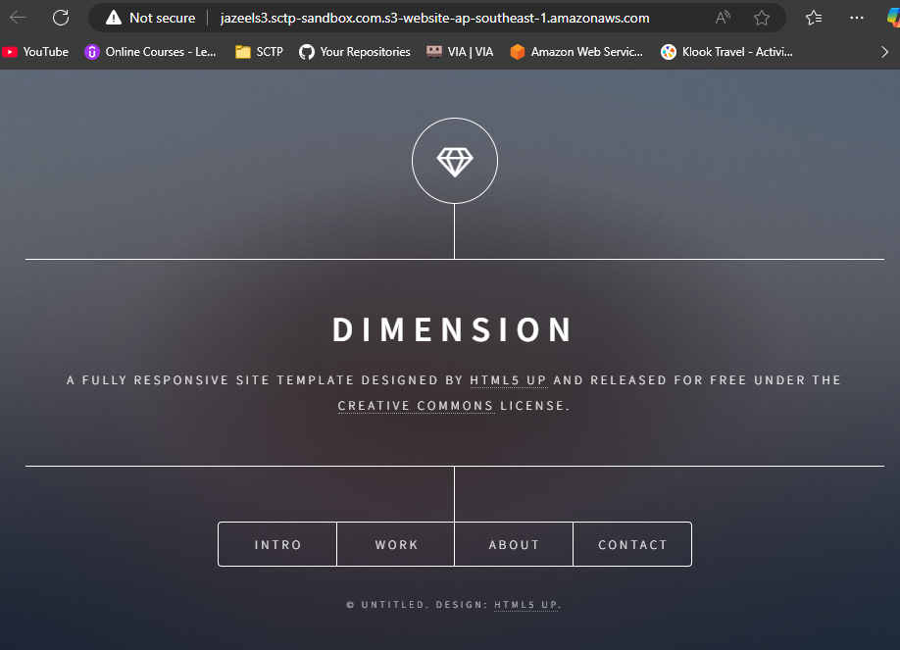

#### Part 4: Set up Route53 record to point to your bucket

Go to Services -> Route53 -> Hosted Zones -> sctp-sandbox.com

* Click “Create Record”.
* Under record name, key in the prefix of your bucket (anything that comes before sctp-sandbox.com in your bucket name. E.g. jazeels3 in my case since my bucket name is jazeels3.sctp-sandbox.com)
* Check “Alias”
* Route traffic to: Alias to S3 Website Endpoint
* Region: Choose the region which your S3 bucket is in
* Your s3 bucket should appear in the search tab if all of your above configurations are right. Choose it.
* Create Records.

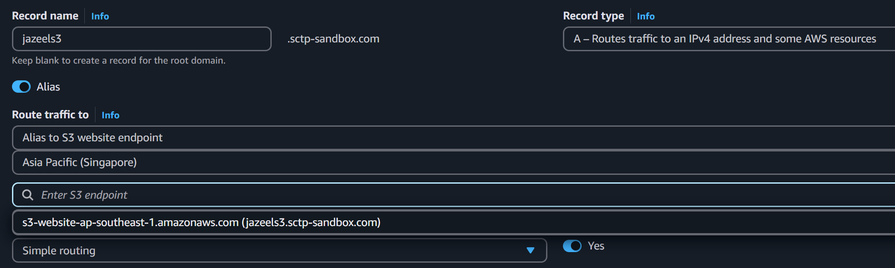

Now you will be above to access your bucket directly through your Route53 record instead of the long s3 website endpoint just now.

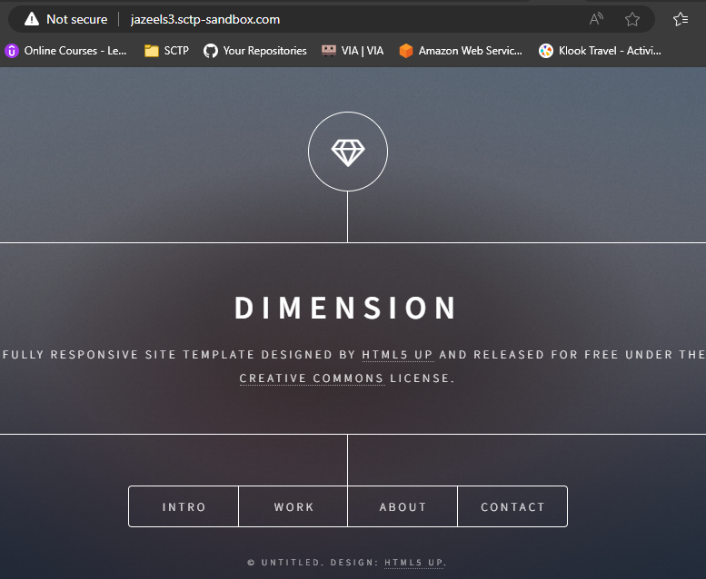

#### Part 5 Clean up

Please remember to delete any resources that you have created in this activity (E.g. empty your s3 buckets and delete them).

### Activity: Terraform Challenge

Recreate the infrastructure from the previous activity in terraform. Once your infrastructure is created, you can use the s3 sync command to upload your files to your s3 bucket.

The code for the Route53 record is already given. Also all the required “Resource” blocks are also given below. Refer to the respective resources’ documentation pages to complete the code.

You can make use of <https://registry.terraform.io/providers/hashicorp/aws/latest/docs/data-sources/iam_policy_document> to form your bucket policy.

| resource "aws_s3_bucket" "static_bucket" {  bucket = "<ADD YOUR NAME HERE>.sctp-sandbox.com"  force_destroy = true  }  resource "aws_s3_bucket_public_access_block" "enable_public_access" {}  resource "aws_s3_bucket_policy" "allow_public_access" {}  resource "aws_s3_bucket_website_configuration" "website" {}  data "aws_route53_zone" "sctp_zone" {  name = "sctp-sandbox.com"  }  resource "aws_route53_record" "www" {  zone_id = data.aws_route53_zone.sctp_zone.zone_id  name = "" # Bucket prefix before sctp-sandbox.com  type = "A"  alias {  name = aws_s3_bucket_website_configuration.website.website_domain  zone_id = aws_s3_bucket.static_bucket.hosted_zone_id  evaluate_target_health = true  }  } |
| --- |